Design and Implementation of Mobile Applications

Oleggo

Falci Angelo
Gallego Julian

Teacher: Baresi Franco

Design document
Chapter 1
Introduction
1.1 Purpose
This document is intended to help understand and evaluate design and prototyping steps taken for the mobile application “Oleggo”, explaining both the application domain and the system that you want to accomplish. It explain the feature of Oleggo, the main component we used and the interface we implemented for the user.
This project is implemented as an outcome of the project “Design and Implementation of mobile applications”.

1.1.1 Intended audience
This document is realized for all people participating in and/or supervising the project:
- Expected audience of this document is the developers and anyone who in-tends to develop on this program
- Developers who can review project's capabilities and more easily understand where their eforts should be targeted to improve or add more features to it (it sets the guidelines for future development).
- Project testers can use this document as a base for their testing strategy as some bugs are easier to find using this document. This way testing becomes more methodically organized.
- End users of this application who wish to read about what this project can do.

1.2 Scope
The goal of Oleggo is to create an application that can be used by students to take notes or look for a word in a fast way to reduce the dead times. An other advantage is that the students can have always with them their notes and a personal dictionary with the words that were more complicated for them. They also can save like favorite the most important note in order to find them in the home page.
But it can also be used by anyone that want to save in own phone all books he/she is reading or read in the past and, for each book, save the notes inserted or word searched and also the bookmark.
To take notes with Oleggo will be fast mostly because it is possible insert note or word using a speech recognized alternatively to write it.

1.3 Goals
The system has to provide these features:
[G1] User can insert a new book inserting the ISBN writing it or reading it using the bar-code reader in the app.
[G2] For each book inserted, and not finished yet, user can insert and modify a bookmark.
[G3] For each book inserted user can insert a note writing it or using speech recognize, and he/she can also add the page of the book. The note remain connected to the “main active” book.
[G4] For each book inserted user can search the meaning of a word and add it in her/his personal dictionary. The word it remain connected with the “main active” book so user have a global dictionary and many little dictionary for each book.
[G5] User can change the state of a book in “passive” (books not finished yet), “active” (book user is reading and can change bookmark), “main active” (user can have only one main active book, every word searching or notes added will be connected to this book) and read (book already finished)
[G6] User can choose to see all favorite notes or all notes connected to a certain book.
[G7] User can choose to see all words in the dictionary or all words connected to a certain book.

1.4 Architecture and tools chosen
To develops Oleggo we used the tool Nativescript.
This tool can be used for cross-platform development, so our app can run in Android or IOS system. It is possible code for Nativescript in JavaScript or in TypeScript, for Oleggo we chose the first. Other language used for the graphics are XML and CSS.
Why NativeScript?
There are a lot of motivations.
The main reason is that it offers many powerfully plugin to implement things, like speech recognition, that in other framework are hard to do (we will see all the plugin used).
An other reason is for the graphics. NativeScript offers an huge type of template for mobile application and we combine some of them to implement beautiful graphics components that, without these templates, are very hard to do so beautiful (for example the drawer menu).

1.5 Document overview
This document is divided in four parts with clean and non-ambiguity description of the whole system.
Chapter 1: General description and basic informartion of the system.
Chapter 2: Explanation of the main functionalities with constraints, assumptions and hardware dependencies.
Chapter 3: Specifications of the system functionalities and non-system func-tionalities possible scenarios .
Chapter 4: Use cases and UML models .
Chapter 2
Overall description
2.1 Architecture design
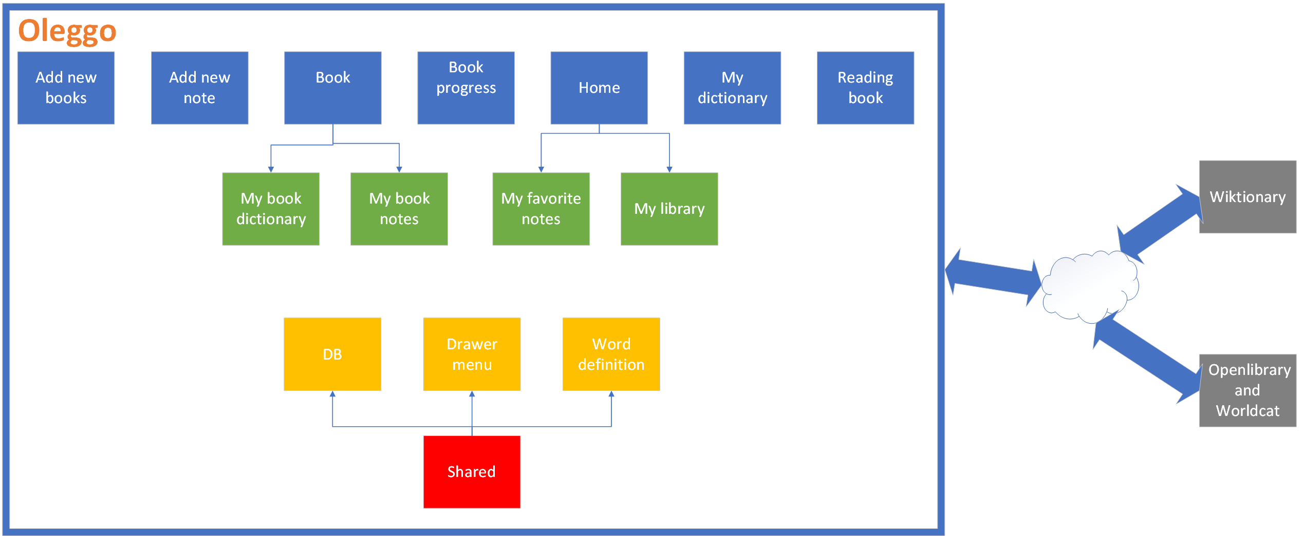
We divide our project in different pages, one for each main pages present in the app, and they are divided in forlder. Each page is divided in graphics (a XML, and eventually, CSS files), in logic (one JS file) and in model that set up the data for the graphics (one JS file). Moreover if a page include more pages we have sub folders for each sub page.
Then we have a folder that contain the components that are used in different page: database, drawer menu and the word definitions.

We will see all blue and green component in the chapter “User Interface”.
The shared component aren’t visible for the user, they are only used by the pages above:
- DB → contain all the query to the database, in this way if we modify something to database we must modify only this class
- Drawer Menu → it is the hide menu that appear in every page if user click button on the left-top or shift the finger from left to right
- Word Definition → it’s include a set of pages that manage the searching of words in Wikitionary
2.2 Use case functional requirements analysis
This chapter shows how users interact with Oleggo in order to reach the different goals. We will see also the flow of actions the user needs to do but we not see the system internals.
We can identify only one group of actors involved in this application:
- Users – who had downloaded and installed the application Oleggo
2.2.1 Insert new book
Actor | Users
Goal | Insert a new book using ISBN
Event flow | - Press New Book voice in the drawer menu  - Insert the ISBN of book writing it or scanning the bar code  - Press ISBN  - If author is not present in online library insert it and continue  - Confirm (or insert if it isn’t present) the number of page in the book and continue
Output conditions | Book is inserted
Exception | - User insert a not valid number of pages (for example insert letters instead of numbers)  - Insert a not valid ISBN

2.2.2 Update bookmark
Actor | Users
Goal | Update the bookmark of a book
Event flow | - Press Home or Reading Books in the drawer menu  - Press in the book we want to modify bookmark  - Press the circle button at left side  - Insert a number and press update progress or press “i have finished button”
Output conditions | - Bookmark updated  - Book state changed and become “read”
Exception | /

2.2.3 Insert note
Actor | Users
Goal | Insert a note connected to “main active” book
Event flow | - Press New Note in the drawer menu  - Insert the note writing it or using speech recognized (pressing “press and speak” and speak) and eventually modify it  - Optionally it possible insert a number of page  - Press add quote
Output conditions | - Quote added and connected to the “main active” book (on default the quote isn’t favorite)
Exception | - If there isn’t any “main active” book the quote isn’t added

2.2.4 Search a word
Actor | Users
Goal | Search and save the meaning of a word connected to “main active” book
Event flow | - Press New Note in the drawer menu  - Insert the word writing it or using speech recognized (pressing “press and speak” and speak) and eventually modify it  - Press look for the word
Output conditions | - Word’s meaning saved and connected to the “main active” book
Exception | - If there isn’t any “main active” book the word isn’t added

2.2.5 Change state of book
Actor | Users
Goal | Change the state of a book (passive, active, main active or read)
Event flow | - Press Home or Reading Books in the drawer menu  - Press in the book we want change the state  - Press in the big, center button more times to change state in “main active”, “active” or “passive”  - If we finish the book see the “update bookmark” table above
Output conditions | - The state of the book is changed
Exception | /

2.2.6 See all favorite notes
Actor | Users
Goal | See all favorite notes
Event flow | - Press Home→My Favorite Notes in the drawer menu
Output conditions | - Show all favorite notes
Exception | /

2.2.7 See all words
Actor | Users
Goal | See all words searched and saved
Event flow | - Press My Dictionary in drawer menu
Output conditions | - Show all words in the dictionary with their meaning in alphabet order
Exception | /

2.2.8 See the notes of specific book
Actor | Users
Goal | See all notes connected to a specific book
Event flow
Output conditions
Exception

2.2.9 See the words of a specific book
Actor | Users
Goal | See all words, and their meaning, connected to a specific book
Event flow
Output conditions
Exception

2.2.10 Remove a word
Actor | Users
Goal | Remove a word from dictionary
Event flow
Output conditions
Exception

2.2.11 Remove a note
Actor | Users
Goal | Remove a note
Event flow
Output conditions
Exception

2.2.12 Modify an existing note
Actor | Users
Goal | Modify an existing note
Event flow
Output conditions
Exception
2.3 Sequence diagrams
In this chapter we will model the flow of logic within our system in a visual manner that will enable us to document and validate our logic for further analysis and design purpose. We will present the most important interactions between the system and the user.

